29th April, 2022

The Human Resources Director
SOBO/Castel
P O Box
Blantyre

Dear Sir/Madam,

RE: WITHDRAWAL OF EXE SILVER AND VIP SILVER SCHEMES

We write to inform you that following a review of our medical schemes offering, it was noted that some medical schemes that are offered to some corporate members are no longer sustainable. The EXE Silver and VIP Silver are some of the schemes that are no longer sustainable.

As a result of the foregoing, a decision has been made to terminate these Scheme offerings with immediate effect. As per Scheme Rules, the three months’ notice for termination starts on 1st May, 2022, and these schemes will no longer be available after 31st July 2022. SOBO/Castel is required to choose a scheme among our generic schemes, that is Executive and VIP Schemes.

Kindly note that the monthly contribution rates will be revised in the next financial year beginning 1st July 2022. An increase range of 20 to 25% is expected for the same.

Hoping the foregoing is in order.

Yours faithfully,
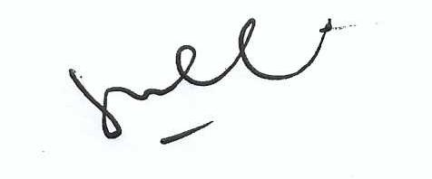
Bernard Ambali
Chief Commercial Officer

